Tech Nation Visa — Global Talent (Exceptional Promise)
Criteria: Optional Criteria 3 — Product & Engineering Impact
Applicant: Odeyemi Olusegun Israel

OC3-3: Integrity Architecture, RBAC Enforcement, and Bybit-Class Attack Prevention

Table: OC3-2 Evidence Summary
Claim | Code / File | Verification
Bybit-class UI attack prevention | ui-integrity.ts — 4-layer hash integrity check | frontend/frontend/src/lib/ui-integrity.ts
Six-tier RBAC enforcement | rbac_config.json shared across Flutter + Next.js | frontend/shared/rbac_config.json
War Room dashboard (R3–R6) | Next.js App Router; live alerts, sanctions panel | frontend/frontend/src/app/
Flutter Focus Mode (R1–R2) | Riverpod + go_router; consumer wallet UI | frontend/amttp_app/lib/
Model explainability / audit | Decision factors + weights per CRITICAL alert | backend/compliance-service/explainability.py
Sole-authored full-stack UI | Flutter (6 platforms) + Next.js dashboard | github.com/segetii/AMTTP/frontend/

Table: OC3-2 Evidence Summary
1. Executive Summary

I built: an enterprise compliance interface with cryptographic UI integrity guarantees, six-tier role-based access control, and AI decision explainability — sole-authored from first line to live deployment. In February 2025, attackers at Bybit replaced the compliance approval interface with a manipulated version, causing staff to unknowingly authorise a $1.5 billion theft. Every War Room screen component carries a cryptographic fingerprint; any substitution is detected and blocked before any approval signature is collected. The architecture is designed to prevent that exact attack class.
2. UI Integrity Implementation

The file ui-integrity.ts provides four layered defences: (1) every screen component carries a unique cryptographic fingerprint; (2) approvals are signed against actual transaction data, not the displayed text; (3) the server independently validates the fingerprint before acting; and (4) a final confirmation is shown in a secure, isolated context. If an attacker replaces any part of the interface, the fingerprints will not match and the transaction is blocked before any approval can be given.
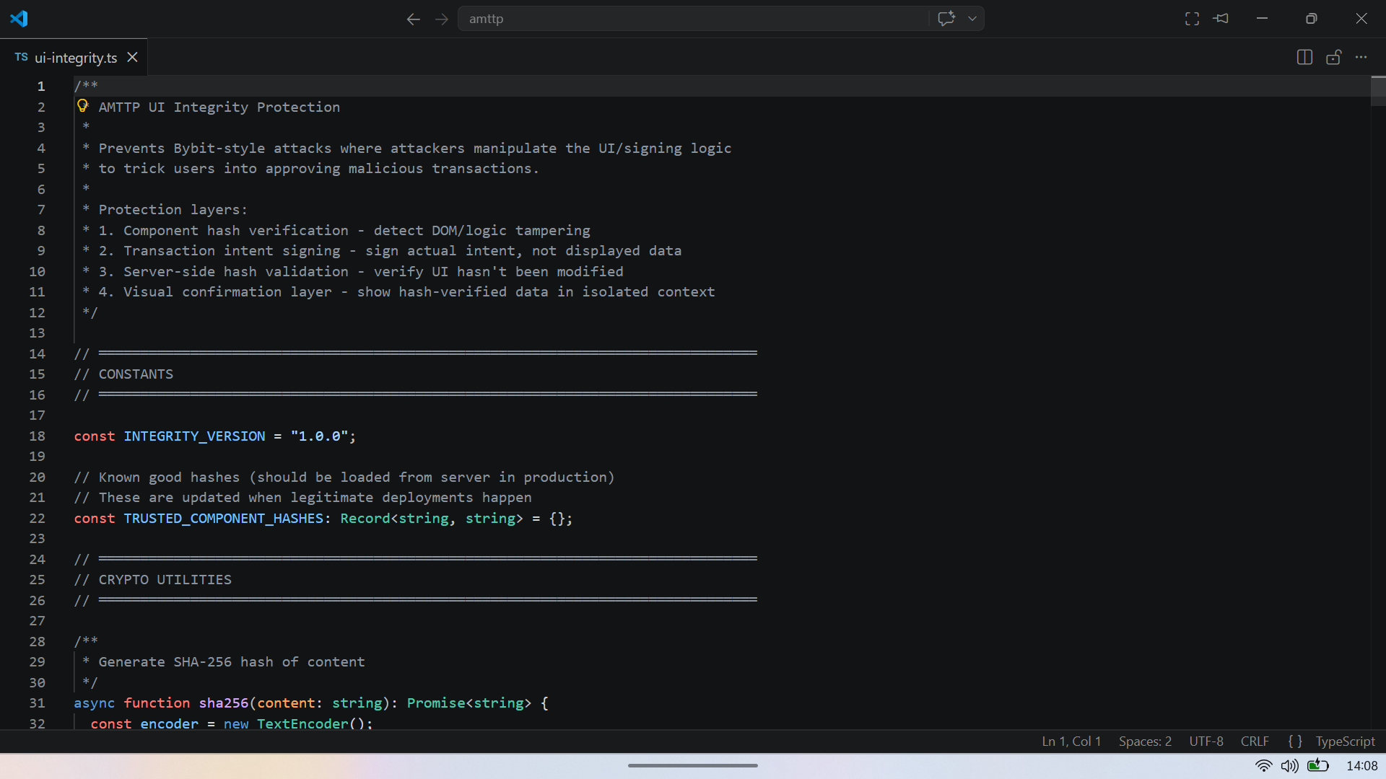
Figure 1: ui-integrity.ts lines 1–32 — header names the Bybit attack vector, lists four prevention layers, implements SHA-256 hashing via Web Crypto API. Any interface substitution breaks every hash.
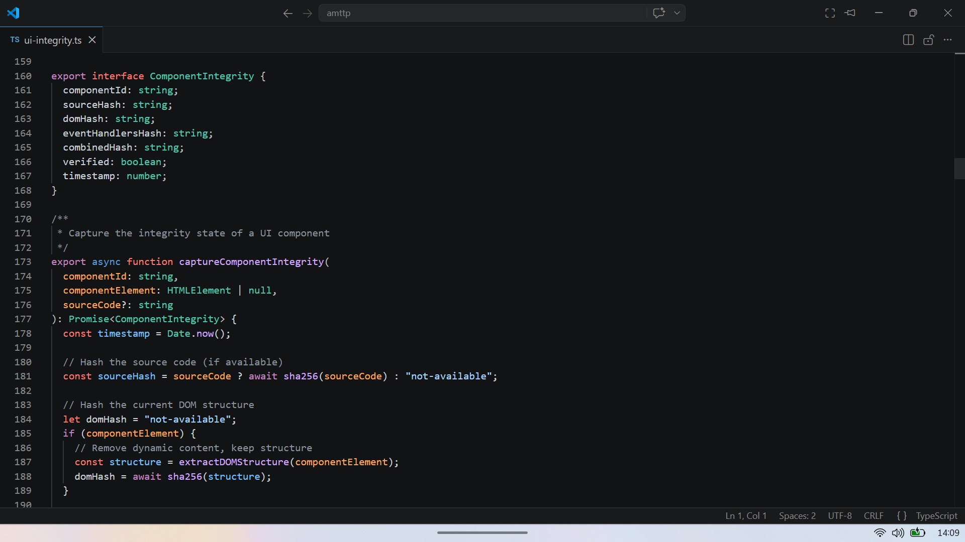

Figure 2: ui-integrity.ts lines 160–190 — four independent hashes (sourceHash, domHash, eventHandlersHash, combinedHash) per UI component. Hashing source code and live DOM independently detects the Bybit attack pattern.

3. Role-Based Access Control

Role | Label | Interface | Key Capabilities
R1 | End User | Flutter (Focus Mode) | Own transactions only
R2 | PEP End User | Flutter (Focus Mode) | Enhanced monitoring, restricted view
R3 | Compliance Officer | Next.js (War Room) | All transactions, report generation
R4 | Risk Analyst | Next.js (War Room) | Detection studio, policy editing
R5 | Administrator | Next.js (War Room) | User management, enforcement actions
R6 | Super Admin | Next.js (War Room) | Emergency override, full audit access
Each role is defined in a shared configuration file used by both the mobile app and the web dashboard. Access restrictions are enforced at the backend server level rather than on the visible interface, meaning they cannot be bypassed by manipulating what appears on screen.

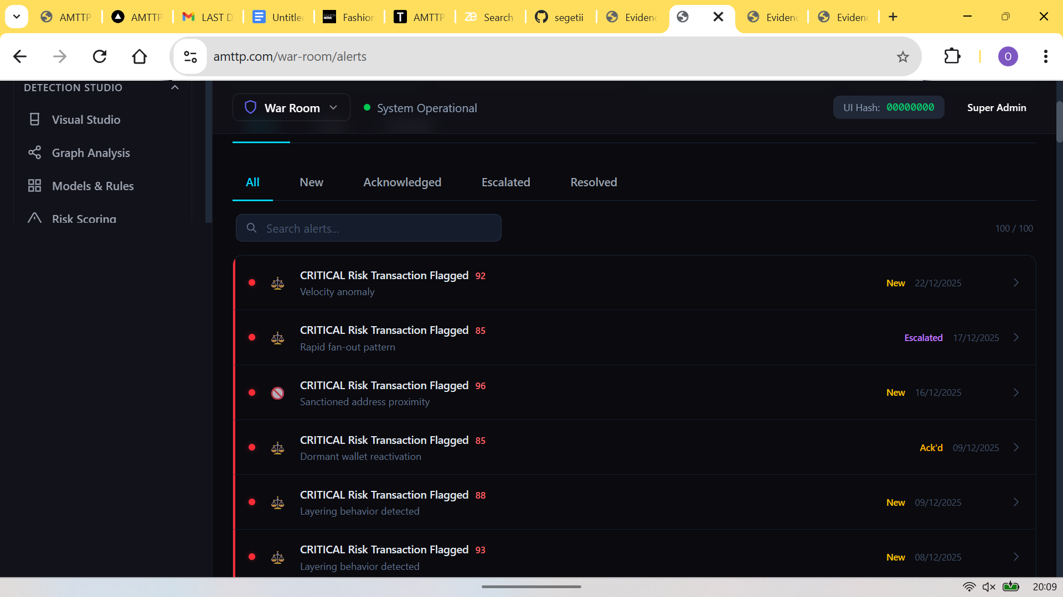
Figure 3: War Room Alerts panel (Compliance Officers and above, enforced server-side) — 100 live critical alerts with severity scores and flag reasons. Role access is denied at the backend, so bypassing the UI restriction gains nothing.

4. Model Explainability and Audit Trail

If an officer receives a "CRITICAL — Block" decision with no reasoning, they cannot detect a manipulated model. The Explainability panel surfaces the contributing factors and their weighting for every automated decision, satisfying FCA/MiCA audit trail requirements.
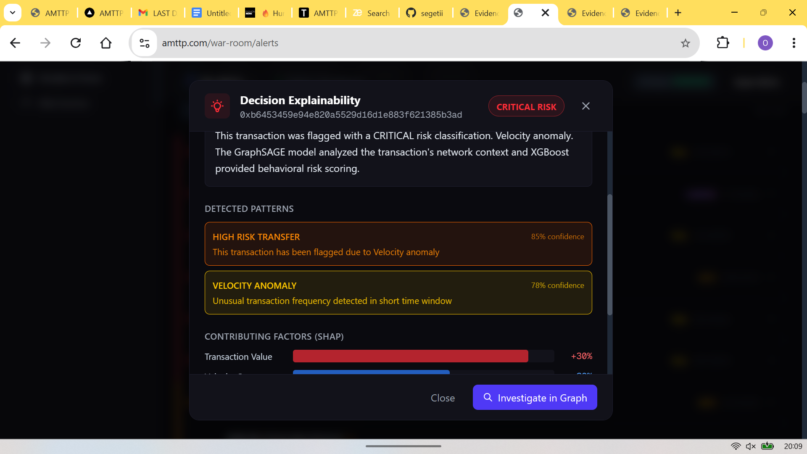

Figure 4: Decision Explainability panel for a CRITICAL alert — contributing factors and their weights: High Risk Transfer 85%, Velocity Anomaly 78%, Sanctioned Address Proximity 65%, with direct link to the graph network view. Satisfies FCA/MiCA audit trail requirements without additional tooling.
5. Consumer-Facing Layer — Flutter Focus Mode (R1/R2)

The War Room serves compliance officers (R3–R6). The complementary consumer-facing layer is a Flutter mobile app targeting R1 (End User) and R2 (Politically Exposed Person). Both interfaces use the same backend and the same RBAC configuration — the product covers the full user spectrum from individual wallet holders to enterprise compliance teams. This dual-interface design is a deliberate architectural choice: a single compliance verdict is surfaced in a contextually appropriate UI for each role.
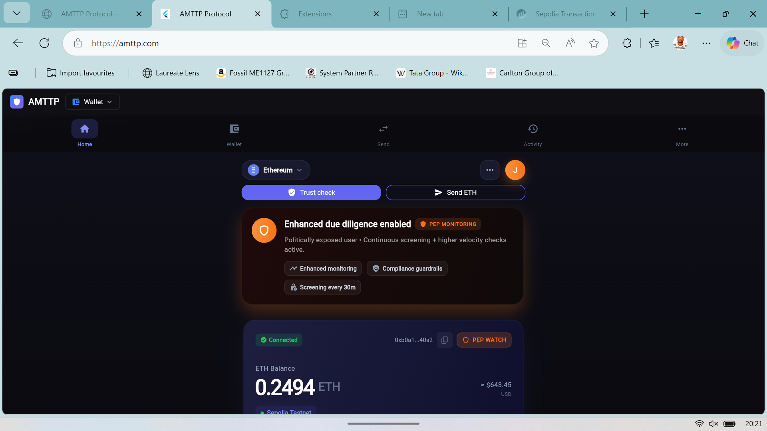 | 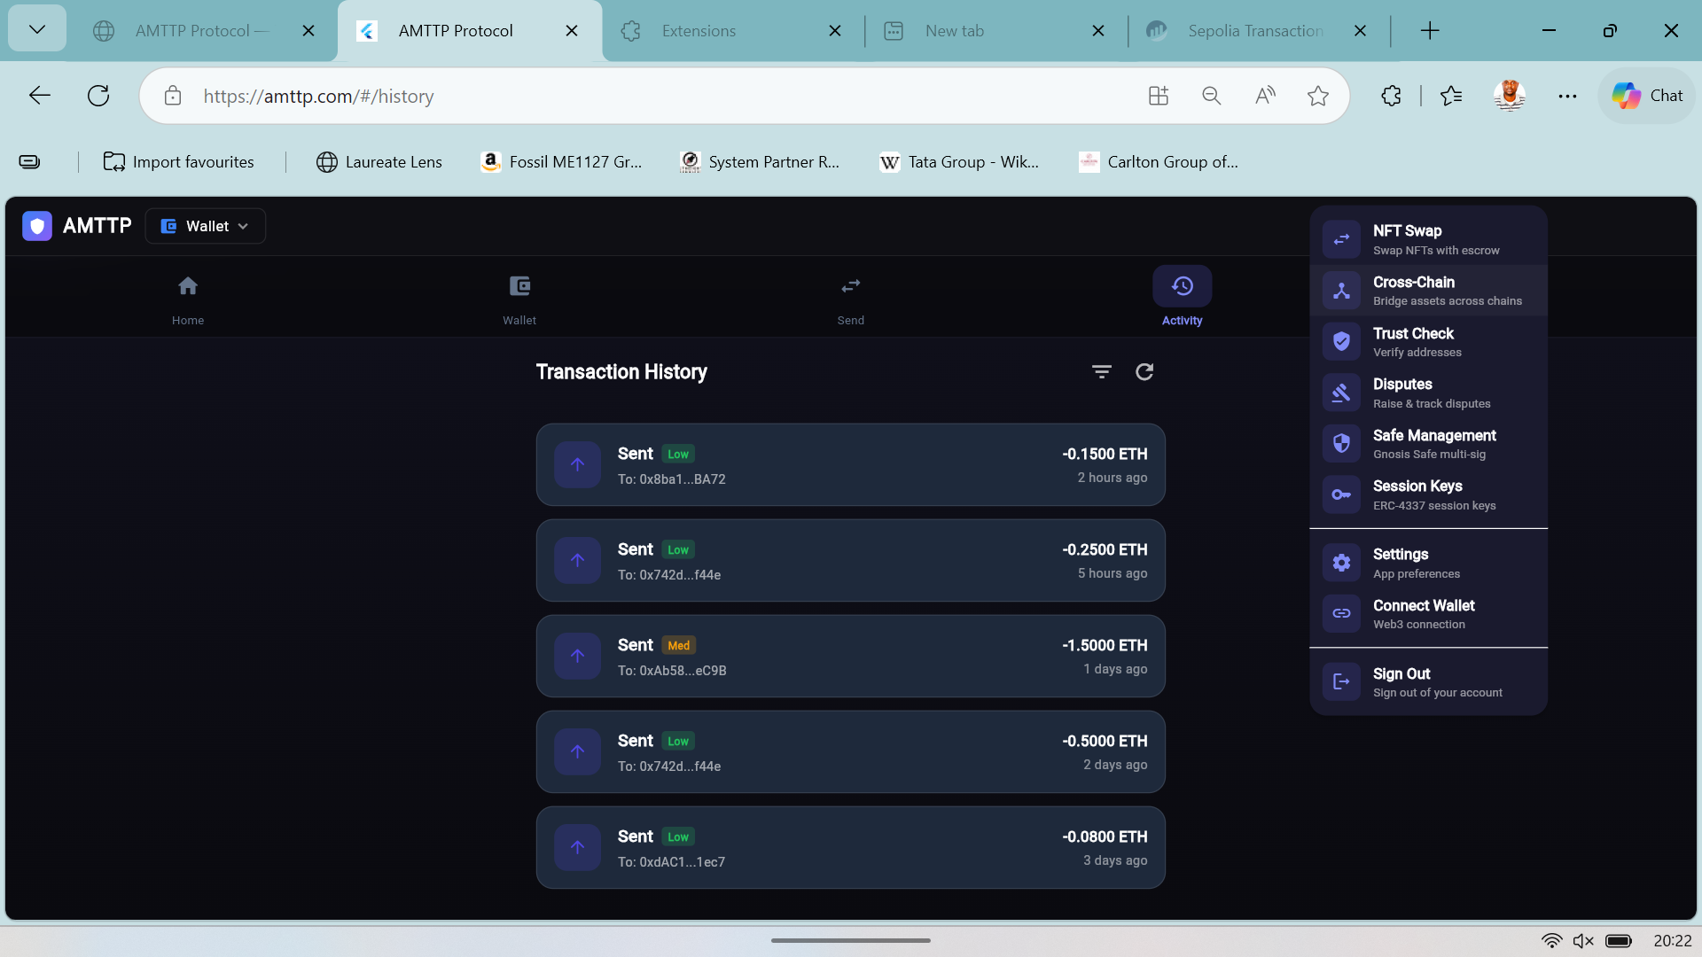
Figure 5: Home screen  (R2 PEP / Enhanced Monitoring) | Figure 6: Activity feed  & navigation menu

Flutter Focus Mode: Home (R2 PEP) and Activity feed. Both screens connect to the same backend and RBAC configuration as the War Room. Sole-authored in Dart; runs on iOS, Android, Web, macOS, Windows, and Linux from a single codebase.
Independent Endorsement (Letter A)
Prof. A. S. O. Ogunjuyigbe independently reviewed the AMTTP platform and noted: “[The system comprises] a compliance orchestration engine of seven parallel microservices … The entire stack operates across 17 containerised microservices. In a university environment, a project of this scope would typically require a principal investigator, multiple postdoctoral researchers, and a team of PhD students. Olusegun has designed and implemented this system independently.” (Letter A — full text submitted as supporting reference letter.)

